- [;

A Project Report On

RESULT MANAGEMENT

Submitted in partial fulfillment of the requirement for the award of the degree

Bachelor of Computer Application (BCA)

Academic Year 2024 – 25

Atkotiya Bhavy (92300527183)

Internal Guide
Prof. Jignesh Kariya



Rajkot-Morbi Road, At & PO : Gauridad, Rajkot 360 003. Gujarat. India.


Faculty of Computer Applications (FCA)



This is to certify that the project work entitled

Library Management System

submitted in partial fulfillment of the requirement for

the award of the degree of

Bachelor of Computer Application

of the

Marwadi University

is a result of the bonafide work carried out by

Atkotiya Bhavy (92300527183)

during the academic year 2023-24

Prof. Jignesh Kariya Dr. Sunil Bajeja Dr R. Sridaran
Faculty Guide |  | HOD |  | Dean

DECLARATION

We hereby declare that this project work entitled Result Management System is a record done by me.

We also declare that the matter embodied in this project is genuine work done by me and has not been submitted whether to this University or to any other University / Institute for the fulfillment of the requirement of any course of study.

Place : Rajkot
Date :

Atkotiya Bhavy (92300527183) Signature :

CONTENTS

Chapters | Particulars | Page No.
1 | SYNOPSIS | 1
2  2.1  2.2 | PREAMBLE  General Introduction  Module description | 2  3  -
3 | REVIEW OF LITERATURE | 3
4  4.1  4.2 | TECHNICAL DESCRIPTION  Hardware Requirement  Software Requirement | 4  4  4
5  5.1  5.2  5.3  5.4  5.5  5.6  5.7 | SYSTEM DESIGN AND DEVELOPMENT  Menu Design  Screen Design  Relationship Diagram (ER)  Algorithm  Flowchart  UML Diagrams  Database Design | 5  5  6  9  11  12  13  17
6 | CONCLUSION | 18
7 | LEARNING DURING PROJECT WORK | 19
8  8.1  8.2 | BIBLIOGRAPHY  Offline References  Online References | 20

TABLE INDEX

Table No. | Title | Page No.
Table 4.1 | Hardware Requirement | 4
Table 4.2 | Software Requirement | 4

FIGURE INDEX

Figure No. | Title | Page No.
Figure 5.1 | ER Diagram | 9
Figure 5.2 | Flowchart | 11
Figure 5.3 | Use Case Diagram | 12
Figure 5.4 | Sequence Diagram | 13
Figure 5.5 | Activity Diagram | 13
Figure 5.6 | Data Flow Diagram | 17

1. SYNOPSIS :

The Result Management System (RMS) is a comprehensive platform designed to streamline the process of tracking, evaluating, and reporting performance outcomes across various sectors, including educational institutions, corporate environments, and governmental agencies. RMS facilitates the efficient management of results, providing a centralized system for input, analysis, and dissemination of performance data.

2. PREAMBLE :

Project Title : Result Management System

2.1 GENERAL INTRODUCTION :

Welcome to the Result Management System (RMS), a robust platform designed to streamline the management and analysis of performance outcomes. This system simplifies processes for recording and evaluating results, generating reports, and overseeing performance metrics. With user-friendly interfaces and efficient functionalities, the RMS aims to enhance organizational efficiency and improve user experience. From tracking academic grades to evaluating project outcomes, this system provides essential tools to optimize result management. Whether handling performance evaluations or generating detailed reports, RMS is tailored to meet the needs of modern institutions effectively.

FEATURES :

Features of the Result Management System:

- Add Result: Administrators can easily input new performance results into the system, including details such as student or employee names, performance metrics, and evaluation dates.
- Remove Result: This feature allows administrators to remove outdated or incorrect results from the database, ensuring data accuracy and relevance.
- Update Result: Administrators can update existing performance records, including correcting errors, revising scores, or modifying evaluation criteria.
- Manage Users: This feature enables administrators to manage user information, including registration details, performance history, and any related feedback or comments.
- Manage Results: Administrators can efficiently manage results across various categories, including categorizing performance data, assigning evaluation criteria, and tracking overall performance status.
- View Records: Administrators have access to comprehensive records of all performance data, including detailed information on results, metrics, and historical trends.
- Issued Result Records: Administrators can view records of results issued to users, including details such as issue dates, evaluation status, and any associated feedback or remarks.
- Search Functionality: Users can search for specific performance results using various criteria such as name, performance metrics, or evaluation dates, making it easy to find detailed information within the system.

3. REVIEW OF LITERATURE :

The literature on Result Management Systems (RMS) highlights the transformative role of technology in streamlining academic operations and enhancing the overall user experience for both administrators and students. As educational institutions increasingly adopt digital tools, several studies focus on the critical features and functionalities that an effective RMS should offer to meet the evolving needs of users.

Research by Patel et al. (2020) emphasizes the importance of user-friendly interfaces and robust functionalities in Result Management Systems. The study underlines essential features such as result entry, grading, and report generation, along with the ability to handle diverse grading systems. Additionally, they highlight the importance of student information management for easy tracking of academic progress across different semesters and courses.

Further, Singh and Gupta (2021) explore key components of RMS, including data security, user access control, and integration with other institutional systems like Student Information Systems (SIS). They stress that a secure, role-based access control (RBAC) mechanism ensures that sensitive data is only accessible to authorized personnel, while allowing for efficient data management across various stakeholders.

In addition, Jones and Brown (2020) discuss the role of automation in Result Management Systems. They point out that automated grading, result entry, and calculation help reduce administrative workload, minimize errors, and speed up result processing. They also emphasize the need for features like automated notifications and result publishing systems to keep students and faculty informed about academic performance in real-time.

Studies by Garcia and Martinez (2018) highlight the impact of data analytics in modern Result Management Systems. The integration of real-time analytics allows for the identification of academic trends, performance patterns, and potential issues, providing valuable insights for educators and administrators. These analytics also enable data-driven decision-making and help tailor educational strategies to improve student outcomes.

Moreover, Kim and Lee (2017) explore how integrating cloud-based technologies and mobile accessibility in RMS can increase scalability and accessibility, particularly in regions with limited resources. Cloud solutions offer cost-effective ways to manage large datasets, while mobile-friendly interfaces improve access to results and academic information for students and faculty alike.

Overall, the literature underscores the importance of incorporating key features such as automated grading, data security, analytics, mobile access, and integration with other institutional systems in Result Management Systems. These features help to optimize academic operations, ensure data integrity, and enhance the experience for students, faculty, and administrators in the digital age.

4. TECHNICAL DESCRIPTION :

The platform will be developed using a combination of the following technologies:

1. Language : Python

2. Search Functionality :

4.1 HARDWARE REQUIREMENTS :

- RAM : Minimum 4 GB
- PROCESSOR : 11th Gen Intel(R) Core(TM) i5-10300H CPU @ 2.50GHz 2.50 GHz
- VERSION : Windows 8,10 & 11.
- SYSTEM TYPE : 64 Bit operating system.

4.2 SOFTWARE REQUIREMENTS :

- USED SOFTWARE : Python IDLE
- USED DATA BASE : Sqlite3

5. SYSTEM DESIGN & DEVELOPMENT :

5.1 MENU DESIGN :

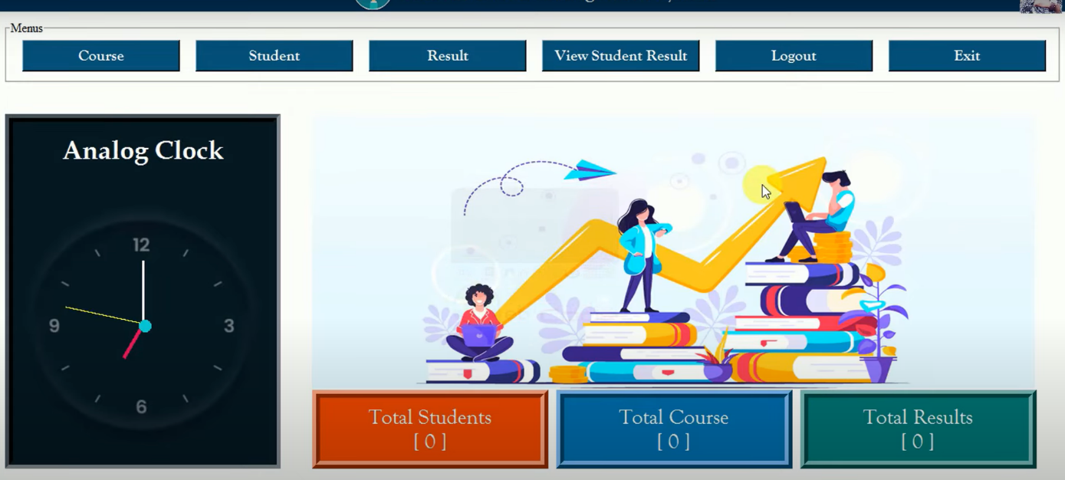

There Are 8 Modules In My Project.

1. Login
2. Dashboard
3. Add Courses
4. Add Examination
5. View Results
6. Results
7. Logout
8. Exit

5.2 SCREEN DESIGN :

- Login Page :

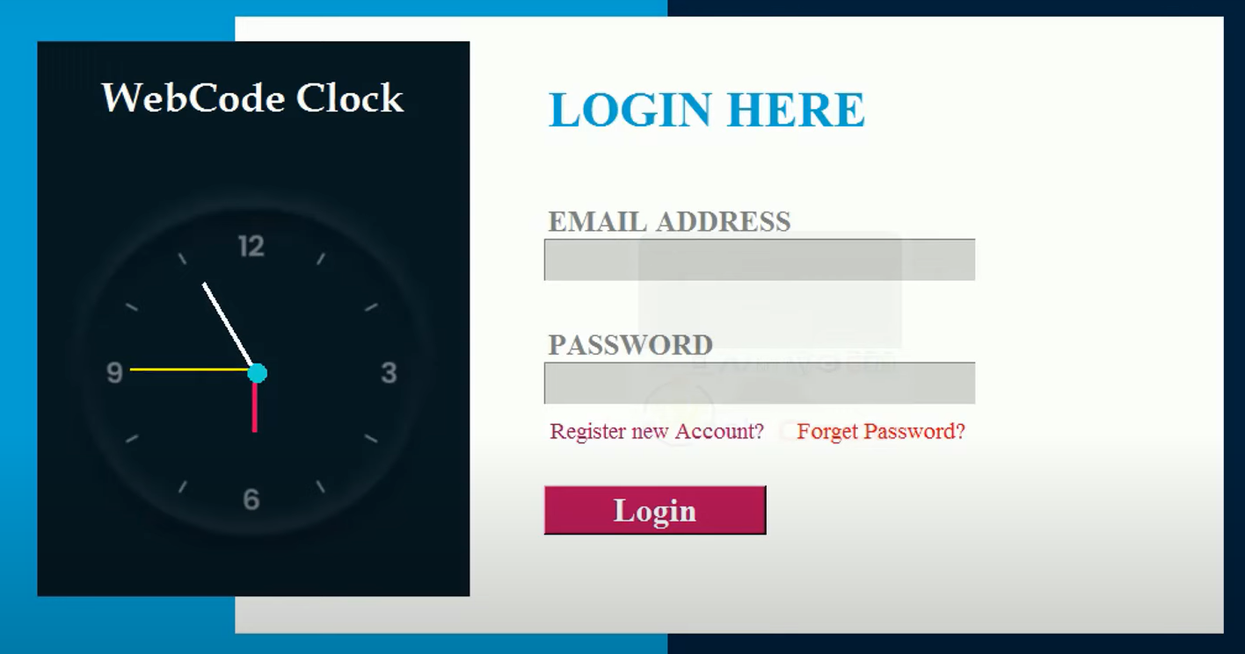

When Code is Run 1st User See The Main Menu Of Library Management System, There Are 2 Options. In Main Menu User Must Requried To Login or Signup To Continue.

- Home Page :



- Manage Course Page :

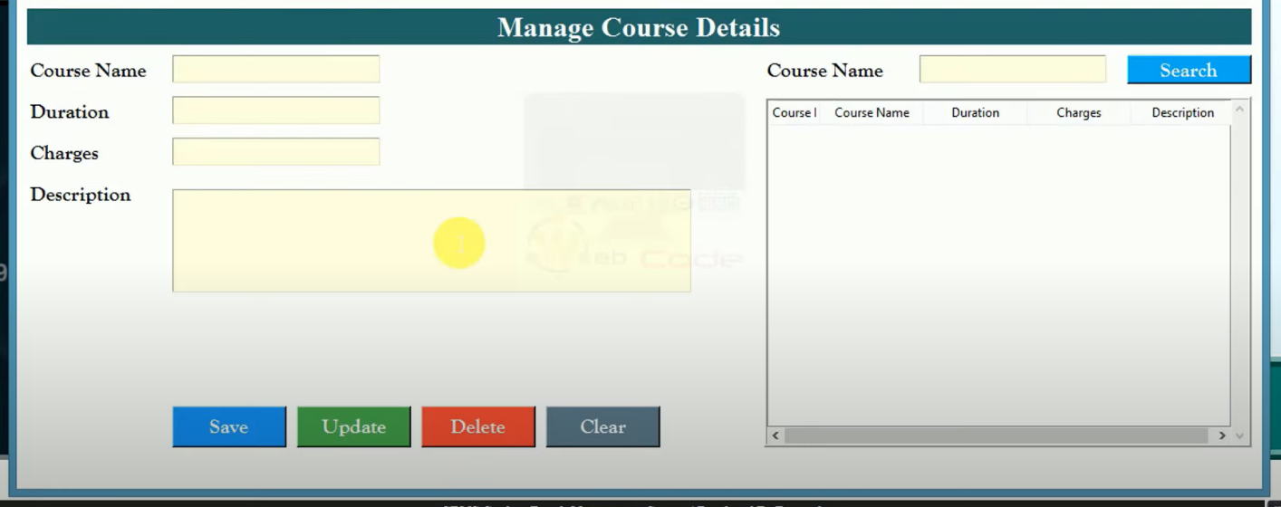

- Manage Student Page :

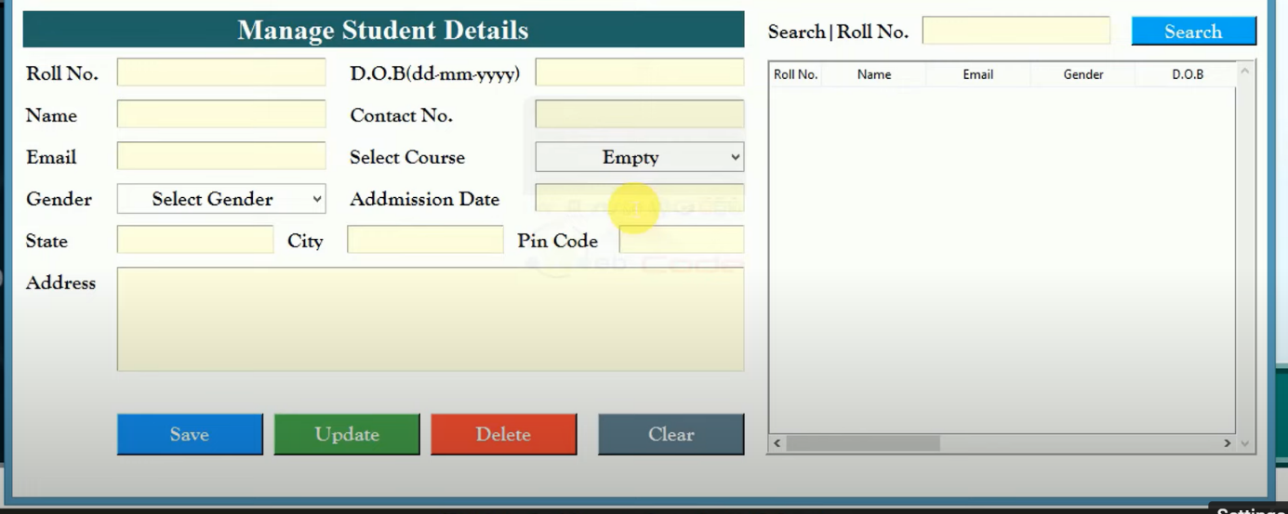

- Results Page :

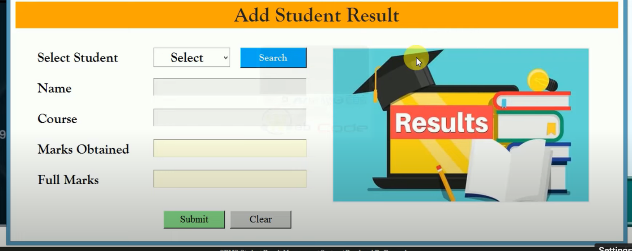
- View Results Page :

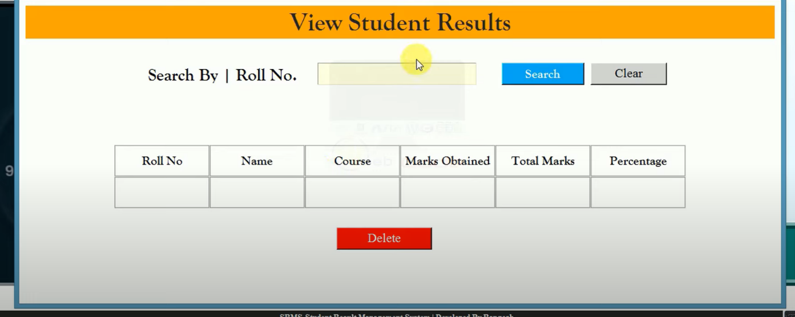

5.3 ER DIAGRAM :
Give
Results
DASHBOARD
OF RMS

SEE
SIGN UP
LOGIN
REGISTER
PASSWORD
USER NAME

USER NAME

EMAIL

PASSWORD

Add
Courses

Add
Students
View
Results

Que. 1

Que. 2
Give
Answer

Logout
Forget
Password

5.4 ALGORITHMS :

USER :

Here's a high-level algorithm outlining the basic steps a user would follow when interacting with the Results management system:

Step 1: Create Data Structures
- Create data structures to store information about students, courses, assessments, and results.
Add Student:
- Step 2: Prompt the user (e.g., administrator) to enter details of the student (such as name, student ID, contact information, etc.).
- Add the student to the system’s database.
Remove Student:
- Step 3: Prompt the user to enter the student’s identifier (such as student ID).
- Remove the student from the system’s database.
Add Course:
- Step 4: Prompt the user to enter details of the course (such as course title, course code, instructor, etc.).
- Add the course to the system’s database.
Remove Course:
- Step 5: Prompt the user to enter the course identifier (such as course code).
- Remove the course from the system’s database.
Enroll Student:
- Step 6: Prompt the user to input the student’s ID and the course they wish to enroll in.
- Enroll the student in the specified course and update records.
Assign Grade:
- Step 7: Prompt the user to input the student’s ID, course code, and the grade to be assigned.
- Record the grade in the system.
Search Student Results:
- Step 8: Prompt the user to input search criteria (student ID, course code, etc.).
- Display the results and grades for the student based on the search criteria.
Generate Reports:
- Step 9: Generate reports on various aspects such as overall student performance, average grades per course, etc.
User Management:
- Step 10: Add, remove, or modify user information (such as name, role, contact details, etc.).
Exit:
- Step 11: End the program.

5.5 FLOW CHARTS :

USER :

START

ADMIN

LOGIN
NO YES

LOGIN
SHOW
RMS DASHBOARD
YES

ENTER E-MAIL
MANAGE
COURSE & RESULTS

PASS
WORD
VIEW
RECORDS

PRESS
LOGIN btn
STOP

5.6 UML DIAGRAMS :

Class diagram :

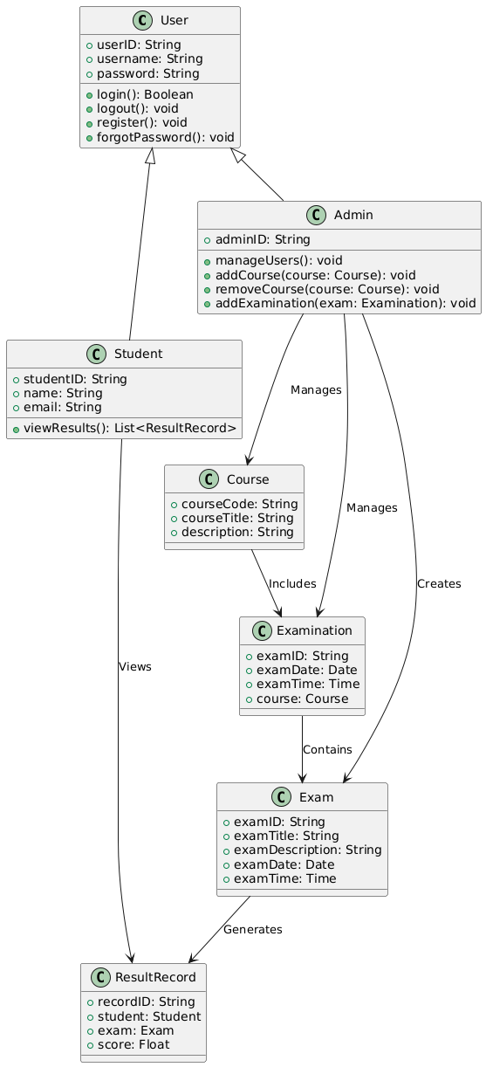

Use Case Diagram :

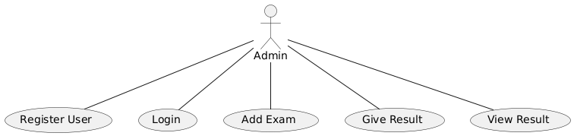

Activity Diagram :

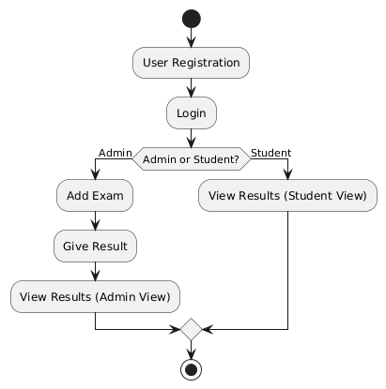

Sequence Diagram :

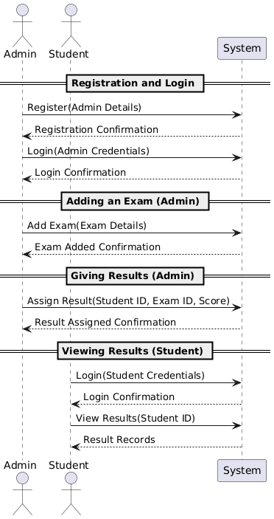

Data Flow Diagram :

RESULT
MANAGEMENT
SYSTEM

USER INTERFACE

5.7 Data Base Design :
EXIT
GIVE RESULT
VIEW RESULT
LOGOUT
MANEGE EXAM
MANAGE STUDENT
LOGIN
SIGNUP
DASHBOARD

User Register Table :

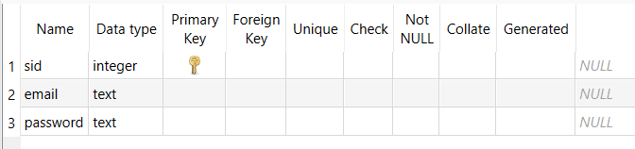

Student Details Table :

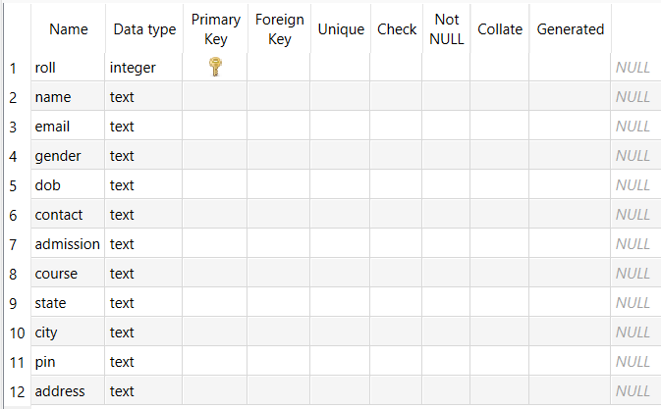

Course Details Table :

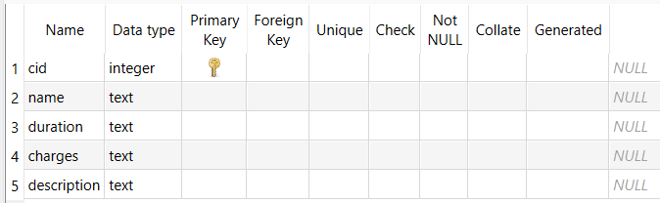

Result Details Table :

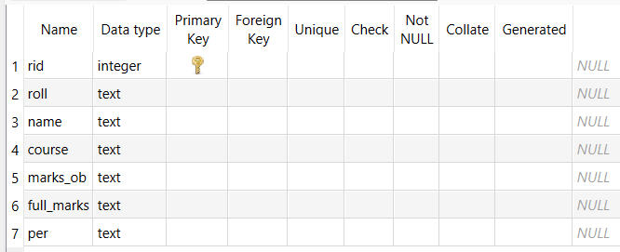

CONCLUSION :

We Have Successfully Implemented The Program . Working Experience With Our Project Guide Is One Of The Unique Experiences. Our Project Guide Prof. Jignesh Kariya Provided Full Support To Us he Always Helped Us Like Our Friend And Companion In Any Situation Or Error On Our Project In A Professional Guide They Provide The Information Required Us In Any Time.

Working Experience With Our Teammates Was Very Unique Together We Learn So Many Things.

Also, The Other Faculty Members Related FOCA Department Had Helped Us In Any Situation By Leap And Bounds.

LEARNING DURING PROJECT WORK :

When We Are Working On The Mini Project, We Learn Lots Of Things, And We Also Get Knowledge About Coding.

We Also Learned How To Use File Handling To Manage.

REFERENCES (IEEE FORMAT)
9.1 Offline References
[1] E. Balagurusamy, Programming in Python, 7th ed. New Delhi, India: McGraw Hill, 2021.
[2] A. Silberschatz, H. Korth, and S. Sudarshan, Database System Concepts, 6th ed. New York, NY, USA: McGraw-Hill, 2019.
[3] R. Elmasri and S. Navathe, Fundamentals of Database Systems, 7th ed. Boston, MA, USA: Pearson, 2016.
9.2 Online References
[4] W3Schools, “Python Tutorial,” [Online]. Available: https://www.w3schools.com/python/. [Accessed: Sep. 6, 2025].
[5] Tutorialspoint, “C Programming Language,” [Online]. Available: https://www.tutorialspoint.com/cprogramming/index.htm. [Accessed: Sep. 6, 2025].
[6] MongoDB Inc., “What is MongoDB?” [Online]. Available: https://www.mongodb.com/docs/manual/introduction/. [Accessed: Sep. 6, 2025].
1. Programing in Python, E. Balagurusamy, McGraw Hill, 7th Edition.

WEB REFERENCES :

- https://www.w3schools.com/c/index.php

- https://www.tutorialspoint.com/cprogramming/index.htm

